1.79: Let the displacement from your camp to the store be 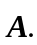

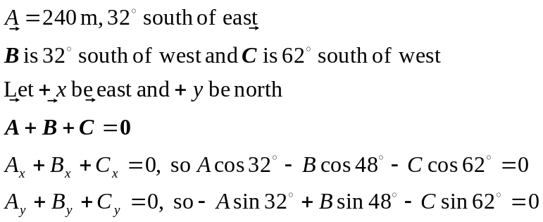
A is known so we have two equations in the two unknowns B and C. Solving gives
B = 255 m and C = 70 m.

